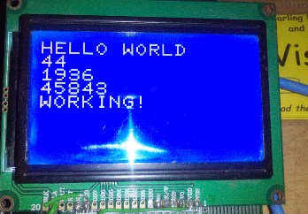So, this is a sort of actually working BASIC program here.

Okay, so it’s not exactly the most complex code ever written, but it is working as it should, and it picks up errors a bit better than the original.